29.76: a) As the bar starts to slide, the flux is decreasing, so the current flows to increase the flux, which means it flows from 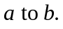
b) The magnetic force on the bar must eventually equal that of gravity.
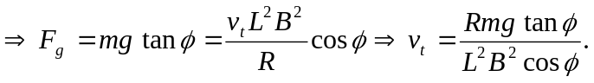
c)
d) 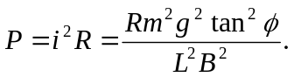
e) 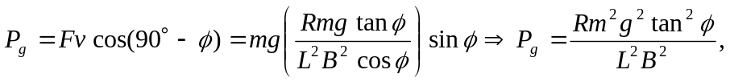 which is the same as found in part (d).

